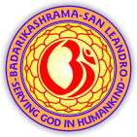
Arise ! Awake ! Stop not, till the goal is reached.
November – December 2026
Om Namo Narayanaya
Na Me Bhakta Pranashyati My Devotee Never Perishes

Sandesha
Sri Krishna-Arjuna Samvada
The sacred philosophical dialogue between Lord Krishna and Arjuna on the battlefield of Kurukshetra, known as the Bhagavad Gita, addresses Arjuna's moral dilemma and outlines the paths to spiritual liberation and righteous action.
• Overcoming Despair: Arjuna collapses in grief, refusing to fight due to the sorrow of slaying his own kinsmen and teachers.
• Eternity of the Soul: Krishna explains that the soul (Atman) is immortal and indestructible, changing bodies like old garments, meaning no one truly kills or is killed.
• Fulfilling Warrior Dharma: Krishna urges Arjuna to uphold his sacred duty as a warrior, warning that abandoning a righteous battle brings dishonor and misery.
• Detached Action (Karma Yoga): Krishna instructs Arjuna to perform his duty selflessly, focusing entirely on the action itself without being attached to success, failure, or rewards.
• Mental Equanimity: The dialogue emphasizes cultivating a steady mind that remains undisturbed by pleasure or pain, victory or defeat.
• The Three Modes of Nature: Krishna describes how human thoughts and behaviors are driven by three cosmic forces: Sattva (goodness), Rajas (passion), and Tamas (ignorance).
• Paths to Liberation: Krishna details distinct spiritual paths to reach the divine, including selfless work (Karma), transcendental knowledge (Jnana), and meditative discipline (Dhyana).
• The Supreme Path of Devotion: Krishna reveals that complete surrender and loving devotion (Bhakti) to the Divine is the highest and most accessible path to peace.
• The Cosmic Form (Vishwaroopa): Krishna grants Arjuna divine vision to behold His majestic and terrifying universal form, revealing Himself as the supreme ruler of time and destiny.
• The Final Surrender: Reassured that the cosmic plan is already set, Arjuna's doubts vanish, his delusion is destroyed, and he picks up his bow to fight.
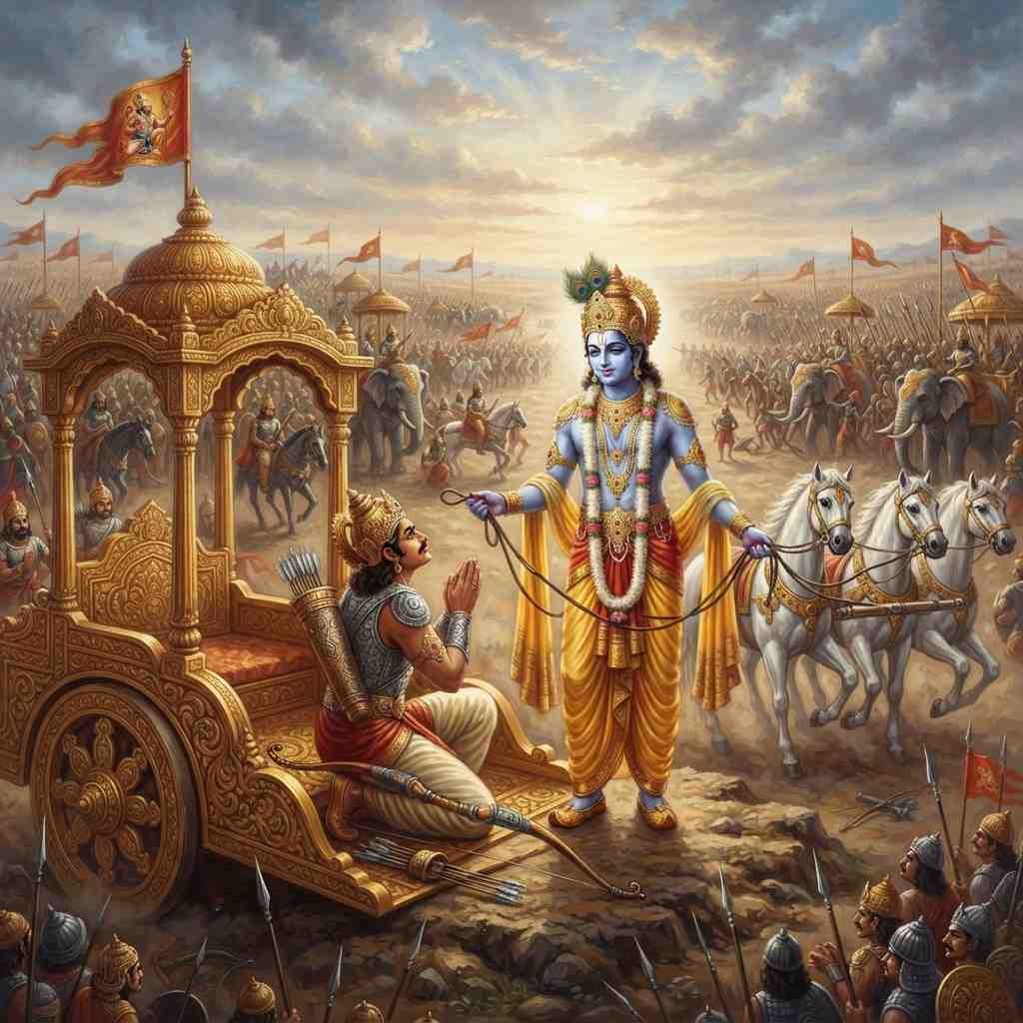

Badarikashrama Diary
Badarikashrama proudly continues to uphold its history of celebrating festivals traditional to Sanatan Sharma (Hinduism) and other international faiths over the last several decades. In the month of September, on Friday the 4th, from 6 PM to 12 Midnight, Sri Krishna Janmashtami was celebrated. The program featured Kirtans by Sargam Shah, Bharatanatyam dance by Shobhana Lundy, Bhajans by Illorah Jha and Kirshna Bhajans separately by Namrata Vartak, Manjusha Joshi and Bharati Bakhta and friends. Several devotees and their families were present to pray and remember the mid-night birth of Lord Krishna. After the mid-night puja and aarti, the devotees partook of the Mahaprasad dinner. Sunday the 6th featured a scintillating talk by one of our long-time devotees, Subita Sudershana, on the topic of “Sri Krishna’s Life and Message”. The talk was followed by an interactive session where she answered many questions from the audience.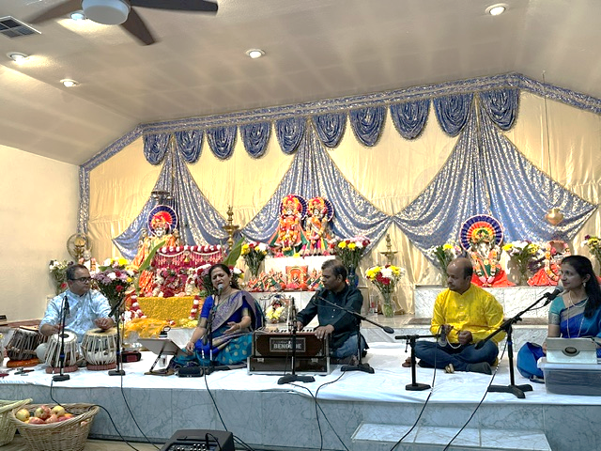
Sri Krishna Janmashtami Celebration

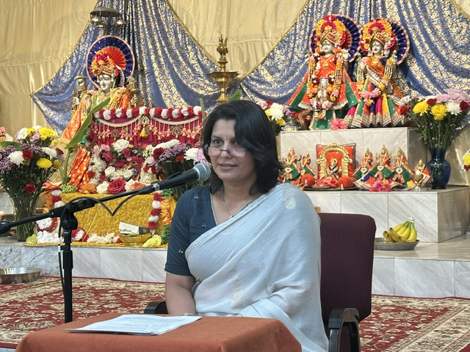

Talk on Sri Krishna’s Life and Message
Sunday the 13th marked the Sri Ganesh Chaturti Celebrations with a homa, followed by a music performance. The program began at 3 PM with the Sri Ganesha homa and puja, in which many devotees and their families participated. This was followed at 4:30 PM with a Bhajan Concert, featuring the well- acclaimed Torvi family. The family-troupe comprised Aarohi Torvi and Sohini Torvi performing vocals, accompanied by Sripad Torvi on the tabla and Ravindra Torvi on the Harmonium. The group performed several bhajans, that mesmerized the packed auditorium, concluding to great applause! After the concert, aarti was performed by VishnuJi. This was followed by mahaprasad dinner.
On Sunday the 20th, Ramanama Sankirtana and Meditation was conducted. Saturday the 26th saw the conductance of the Full Moon Sri Satyanarayana Puja and Katha.
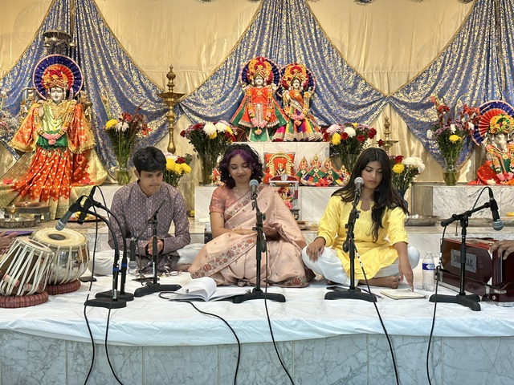

The month of October had its own set of celebrations and events. Navaratri was celebrated from Sunday the 11th to Tuesday the 20th. On all these days, the daily program routine includes a “Sri Durga Saptashati” before dawn, a “Sri Durga Homa” around mid-day, and a “Sri Lalitha Sahasaranama Recitation, Puja and Aarti” in the evening. In addition to this, each day had a unique and different program / event.
Ganesh Chaturti Celebrations
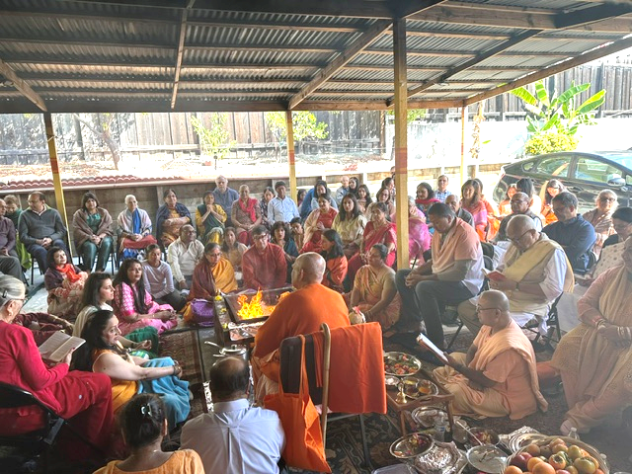

Navaratri Homa

Sunday the 11th featured a 6:30 PM Kirtan by the Prashanth and Pavitra Bhadri family. Friday the 16th hosted a 7 PM music recital by the Saraswathi School, with Saneyee Bhattacharjee and friends performing. Saturday the 17th starting 6:30 PM, “Mata Ki Chowki” devotional songs were rendered by Harjeet Mehndi and friends. The music was accompanied by graceful dancing performed by the devotees present. Sunday the 18th was celebrated as the “Ashtami”. A music concert began at 4:30 PM, featuring a vocal recital by Namrata Vartak, accompanied by Shreyas Vartak on the tabla and Amol Chiplunkar on the harmonium. The troupe performed several bhajans and kirtans, to great applause.

Tuesday the 20th marked the “Vijaya Dashami” celebration. As the concluding day of the Navraratri season, the events were a bit more elaborate. A Durga Homa was conducted starting at 5 PM. From 6:30 PM to 7:30 PM, “Sri Mahishasura Mardini” was performed by Illora Jha and friends. Aarti was performed at 7:30 PM, followed by mahaprasad.
On Sunday the 25th, the “Sharada Purnima” Satyanarayan Puja and Katha was held. On the same day, SwamiJi’s 88th birthday was celebrated, with many of the long-time devotees and patrons of Badarikashrama being present to greet SwamiJi!
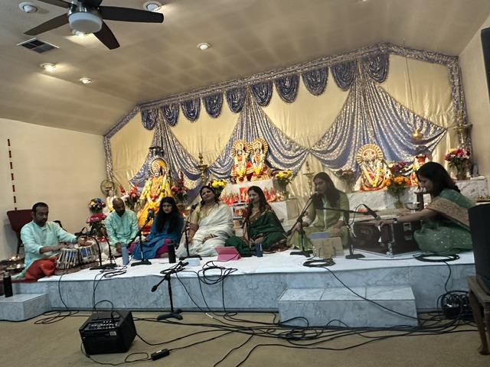
Navaratri Celebration

An Uplifting Update From Madihalli
Srusti C.K. is a student from The Regional Institute of Education, situated in Mysore, in Karnataka, India. Currently completing her second year of undergraduate studies in the Bachelor of Arts and Bachelor of Education field, her University requires her to undergo a “School Attachment Program” as a practical part of her academic training. She chose our Badarikashrama Vidyashala in Madihalli for this exercise, staying on-site for a week, observing the operations and administration of the school, and recording these. Her report includes references to the school’s origins and founding by Swami OmkaranandaJi, and its progression since then.

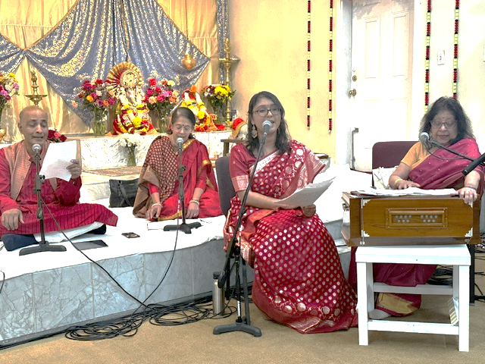

Vijaya Dashami

She includes very positive feedback about the school’s holistic framework and approach towards the advancement of students, from the perspective of academics, physical fitness, culture and spirituality, from the elementary school level, all the way through high school. She noted the awards/accolades received by the school in several areas, from its early days, as well as after transition of management to the Ramakrishna Mission. Special reference has been made to the role of NRIs in the school’s journey. For more information, please click on the following link: Badarikashrama School Attachment Program Report.
Badarikashrama thus continues in its journey of providing selfless service to humanity. Please en-quire with the office on how you can participate in Badarikashrama’s expansion project!!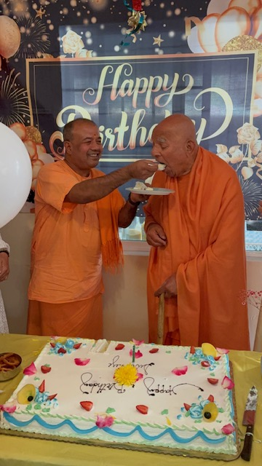
SwamiJi’s Birthday Celebrations

Calendar of Events for November & December 2026

Nov | Timings | Upcoming Programs
Sun, 1st | 11:00 am | Sri Bhagavat Gita Talk by Dr. Devyang Patel; Kirtan by Bansi Patel
Sun, 8th | 2:30 pm | Deepawali Celebration  2:30 pm Maha Lakshmi Homa  4:00 pm Hindustani Concert – Madhuvanti Bhide
Mon, 9th | 6:00 pm | Sri Mahalakshmi Puja and Kirtan
Sun, 15th | 11:00 am | Deepawali & Maha Lakshmi (Talk by Prashant Bhadari)
Sun, 22nd | 11:00 am | Sri Ramanama Sankirtana and Meditation; Bhaktimala by Prashant Bhadari
Thu, 26th | 3:00 pm | Thanksgiving Dinner; Concert by Shubhangi Sakhalkar
Sun, 29th | 10:30 am | Sri Sundarkand Ramayana of Goswami Tulasidas.
Dec
Sun, 6th | 10:30 am | Samuhika 108 Sri Satyanarayana Puja and Katha;  Kirtan By Rita Sahai
Sun, 13th | 11:00 am | Sri Sarada Devi Jayanti Celebration – Talk By Pravrajika Anantaprana (Nun from Vedanta Society SF), Kirtan by Nidhi Kaul
Sun, 20th | 11:00 am | Srimad Bhagavat Gita Jayanti. Talk By Dr. Rajeev Verma Kirtan By -Stanford Bhajan Ensemble
Fri, 25th | 3:00 pm | Christmas Dinner and Concert – Srikant Chary on the Veena
Sun, 27th | 11:00 am | Sri Ramanama Sankirtana and Meditation
Jan 2027
Fri, 1st | 10:30 am | Sri Ganesha Homa and Concert
Sat, 2nd & Sun, 3rd | 9:30 am | Akhanda Ramayana: Sri Ramcharitamanas of  Goswami Tulsidas
Teachings of Sri Ramakrishna | Badarikashrama Next Gen. Project
"God can be realized through all paths. All religions are true. The important thing is to reach the roof. You can reach it by stone stairs or by bamboo steps or by a rope."  "When the flower blooms, the bees come of their own accord. So let the flower of your devotion bloom, and the Lord will come." | Expanding into the future for the Next Generation spreading Vedic culture to all.  Goal: Expand our San Leandro Center to a larger facility. Key features include  - Prarthana Mandir • Large Parking Lot • Cultural Center • Dinning Facilities • Residen-tial Quarters  How to make a tax-deductible donation  Zelle, Venmo, Cash, Checks, Paypal and Em-ployer Matching Funds  Checks can be made to “Badarikashrama”. On the “For” line, please write “Next Gen Project”.

Badarikashrama, USA Center
Badarik@pacbell.net 510-278-2444 Daily Schedule at San Leandro Temple is open between the hours of 8am to 12 noon and 5pm to 7:30pm Temple is Closed Every Thursday Evening aarati daily- 6.30pm
Mondays 6:30 pm: Sri Siva Puja & Aarti
Tuesdays 6:30 pm: Sri Durga Puja & Aarti Poornima Sri Satyanarayana Puja
every fullmoon

